Alvin Edwood Mullins (1875-1946) - Find a Grave Memorial

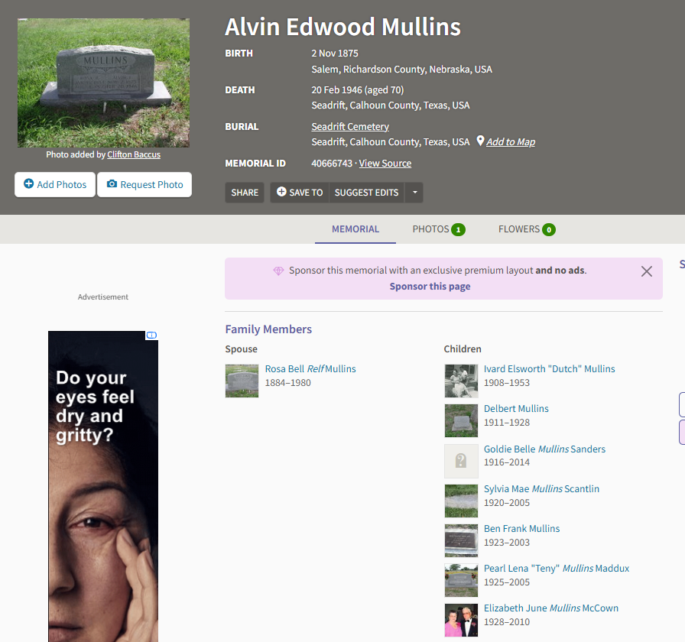

Rosa Bell Relf Mullins (1884-1980) - Find a Grave Memorial
