The Farm
Before I can talk about myself we need to go back to Mountain Park Oklahoma and have a family history lesson that leads to the acquisition of the property that shaped my life. The Mullins family had come from Richardson County Nebraska and may have been involved with one of the Oklahoma land rushes. In the 20’s John Abner Mullis and his wife Nettie (Relf) and his brother Alvin Mullins were living west of Mountain Park Oklahoma. Alvin married Rose ( or Rosie) Relf. The brothers has married sisters. Alvin has a country store beside the old Roosevelt School located a few miles west of the current Roosevelt Ok. When times were tough at the end of the 20’s John Abner and Alvin made some moves. Alvin and his family (including his wife we call Aunt Rose) made their war to Seadrift Texas. John Abner stuck it out in Oklahoma but made some strategic land purchases in Parmer County Texas and Curry County New Mexico. I never was able to meet John Abner or Alvin as they were before my time. Nettie (Relf) Mullins the wife of John Abner Mullins lived into the 1960’s and I was around her for several years when she moved to Friona, Texas. .
John Abner had two children Sarah Francis Mullins (my grandmother, the mother of my father) and “Pete” Mullins who I knew as uncle Pete. .
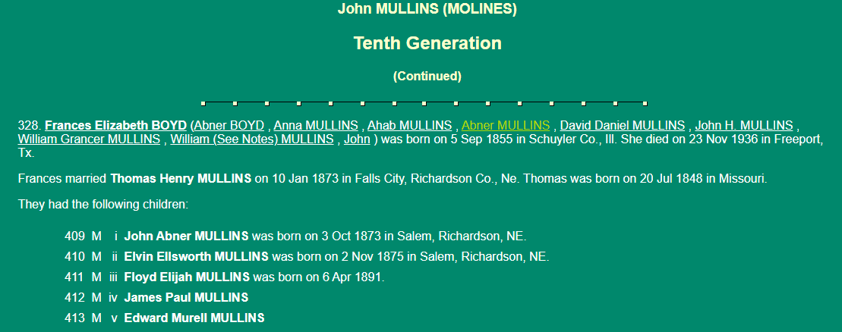
I was a farm boy more than anything else. I was born in 1954 to a family that was very young my father was only 18 my mom had just turned 16 in January 1954. When I was born November 18, 1954 after they had been married on December 29, 1953. and that was common in in those days they loved me very much and took good care of me as best they could they had both come from some difficult situations and come together to form a family that could help mitigate some issues my mother was so very young when she was married she was only 15 and then she turned 16 the next January after they were married in December 29, 1953 I came along in November 1954 to this wonderful couple they lived on the farm and did the best that they could the farm itself had a transfer bit large transformation in 1952 when they first drilled the first water well to irrigate a portion of the land in West TX was drilled on the far northeast corner of the farm at at a location that had an altitude about 40,300 feet and the water flowed in could flowed eastward or southward from this point to of their choosing this water will changed everything for those that had depended on dry land farming caused the crop yields would be increased however a person would have to be there to move the water from point to point each and every day of their life from that point forward what had become what was a passive uh choice of income had become a very active engaged income that irrigation water had to be herded and directed each and every day of their life.

