Παῦλος ἀπόστολος Ἰησοῦ Χριστοῦ διὰ θελήματος
θεοῦ τοῖς ἁγίοις τοῖς οὖσιν ἐν Ἐφέσῳ καὶ πιστοῖς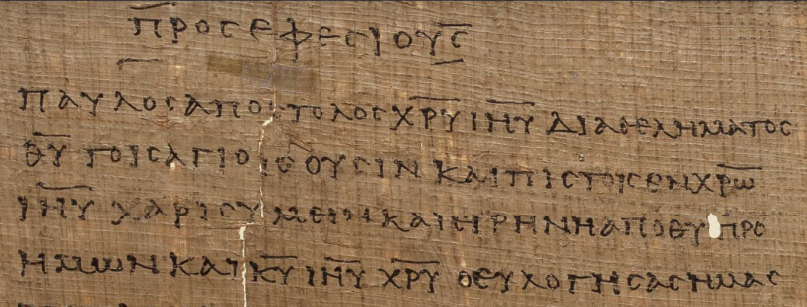 ἐν Χριστῷ
Ἰησοῦ
1:2 χάρις ὑμῖν καὶ εἰρήνη ἀπὸ θεοῦ πατρὸς
ἡμῶν καὶ κυρίου Ἰησοῦ Χριστοῦ

