The Art of the Church Cornerstone
by John Paul Sonnenon May 19, 2020
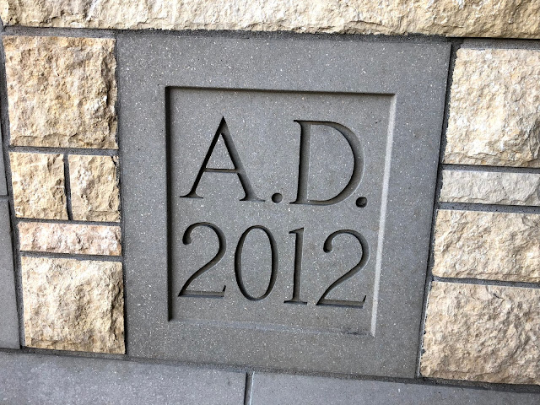
Has much ink has been spilt on the subject of cornerstones? Surely very little. Nevertheless, these, too, can be charming works of bespoke (custom-made) art. Indeed, whenever I visit a church the first thing I like to know is how old the church is. The cornerstone is a holy object (blessed by the bishop) that holds symbolic weight (with a variety of scripture references). The history of the community is contained within the time capsule sealed in the stone, leaving for posterity a cache of historic items intended as a deliberate method of communication with future generations of parishioners. In short, the design of the cornerstone deserves mention. I include several examples I have recently spotted in the Twin Cities. It is my hope this post will give pastors, church architects and building committees a few creative ideas.

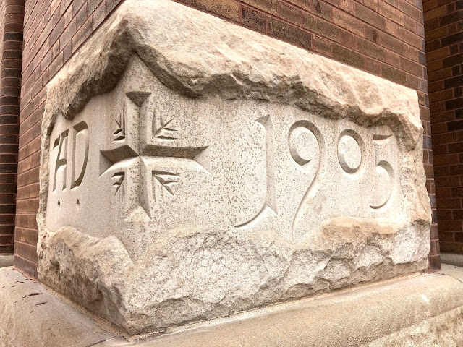

From the German parish of St. Bernard's in St. Paul, Minn.

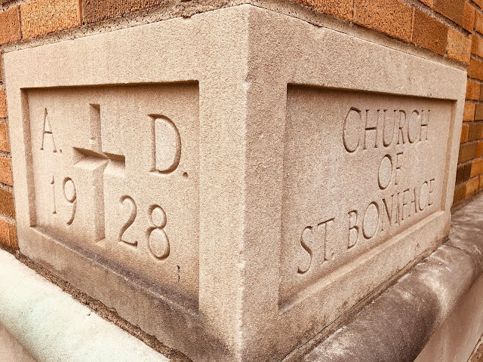
From the German parish of St. Boniface in Minneapolis, Minn.
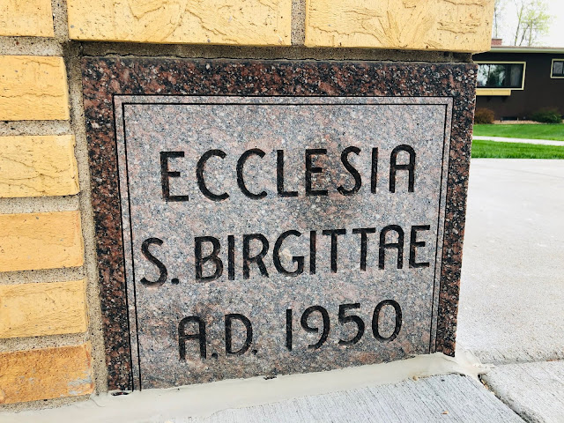
From the Swedish parish of St. Bridget in Linsdtrom, Minn.
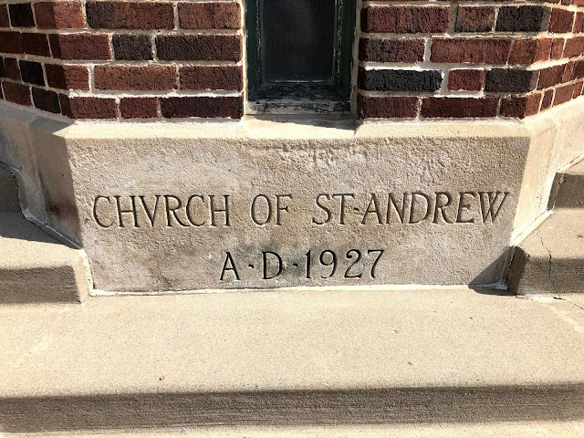
From the parish of St. Andrew in St. Paul, Minn.

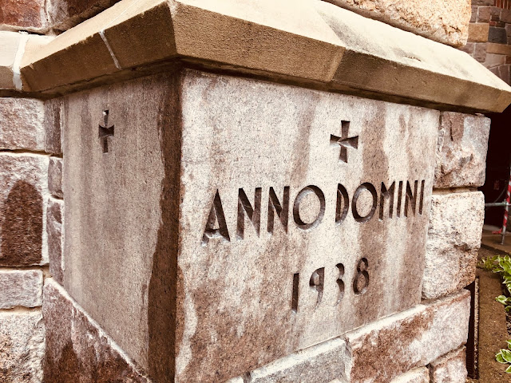

From the parish of the Nativity in St. Paul, Minn.
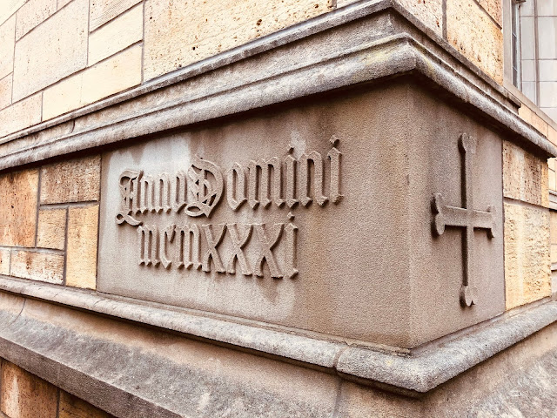

From the University of St. Thomas in St. Paul, Minn.
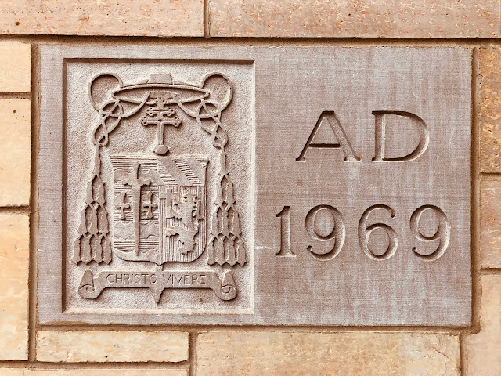
From the University of St. Thomas in St. Paul, Minn.
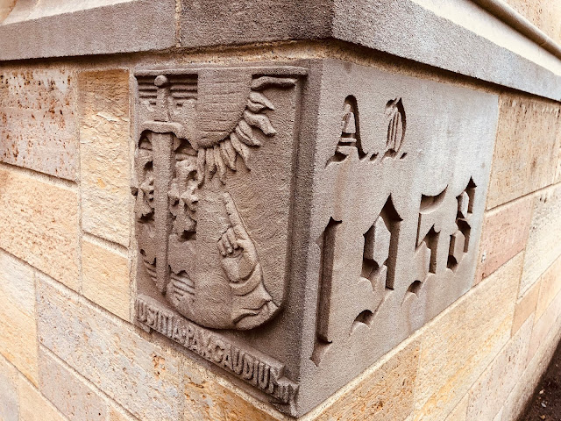
From the University of St. Thomas in St. Paul, Minn.
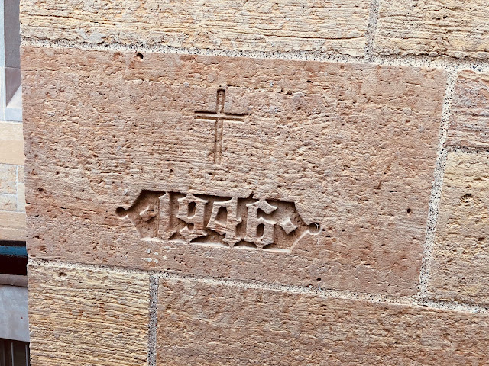
From the University of St. Thomas in St. Paul, Minn.
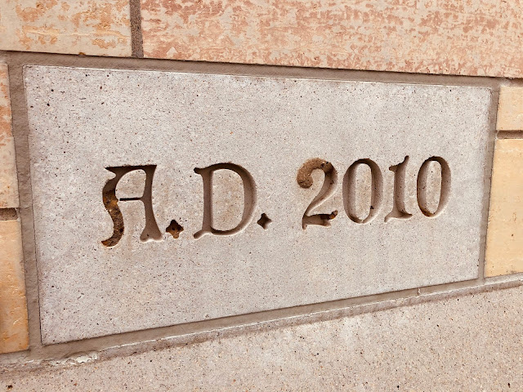
From the University of St. Thomas in St. Paul, Minn.
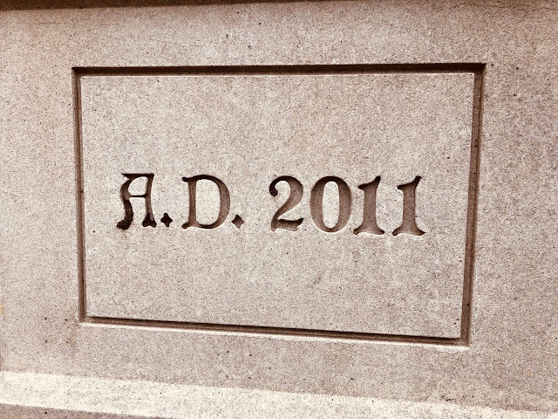
From the University of St. Thomas in St. Paul, Minn.
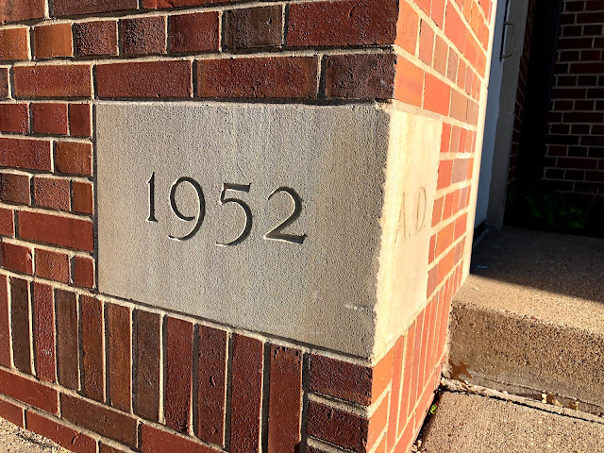
Nativity convent in St. Paul, Minn.
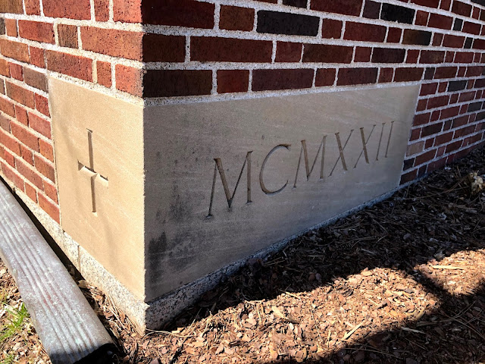
Nazareth Hall Preparatory Seminary in Roseville, Minn.
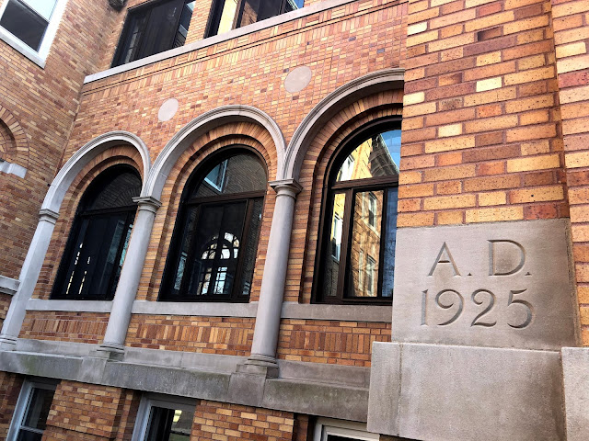
Sisters of St. Joseph of Carondolet convent in St. Paul, Minn.
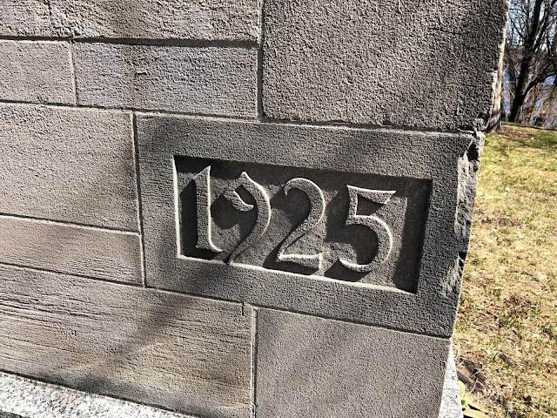
Mater Dei chapel at Nazareth Hall Preparatory Seminary in Roseville, Minn.
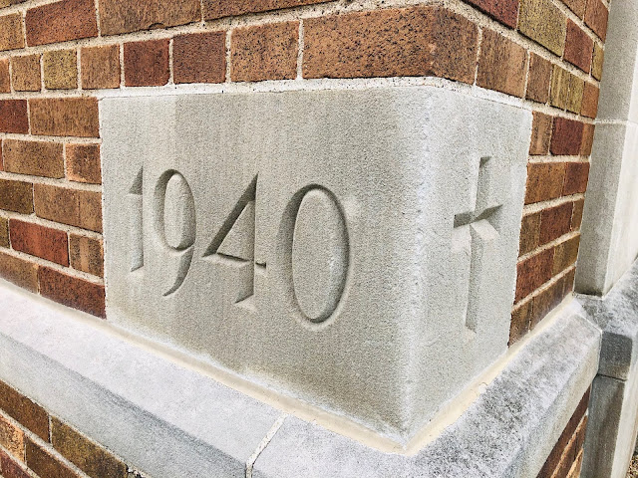
St. Stanislaus parish in St. Paul, Minn.
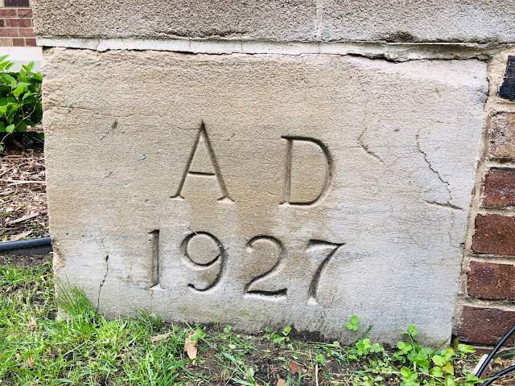
Cretin High School in St. Paul, Minn.
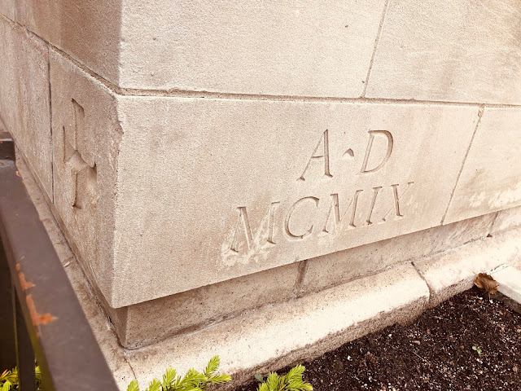
Church of St. Louis in St. Paul, Minn.
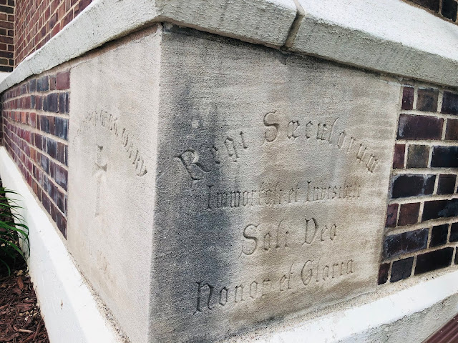
Church of St. Mary in St. Paul, Minn.
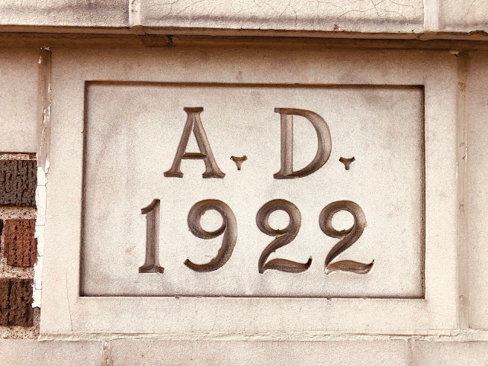
St. Columba's School in St. Paul, Minn.
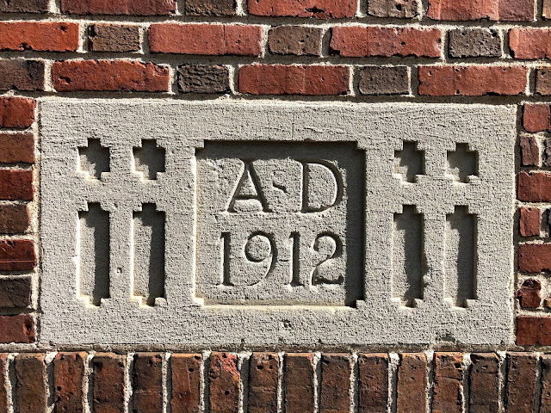
St. Mark's School in St. Paul, Minn.
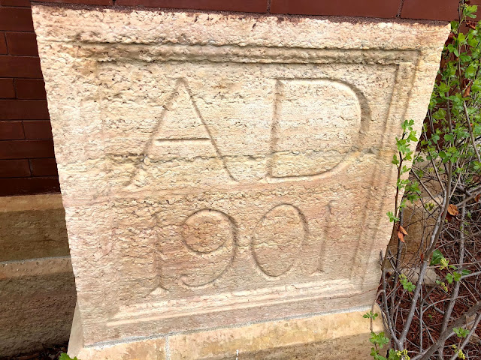
Church of the Ascension in Minneapolis, Minn.
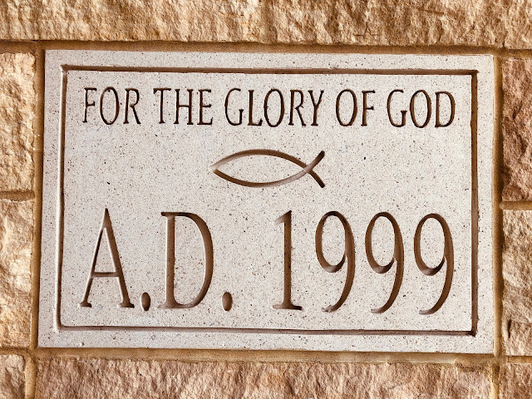
Church of St. Maron in Minneapolis, Minn.
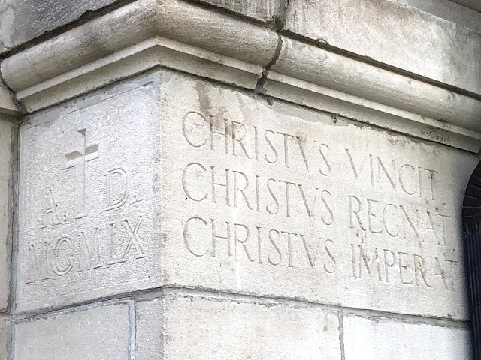
Church of St. Agnes in St. Paul, Minn.
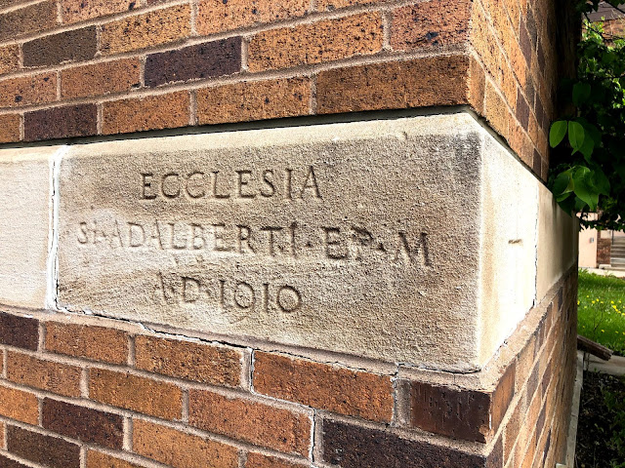
Church of St. Adalbert in St. Paul, Minn.

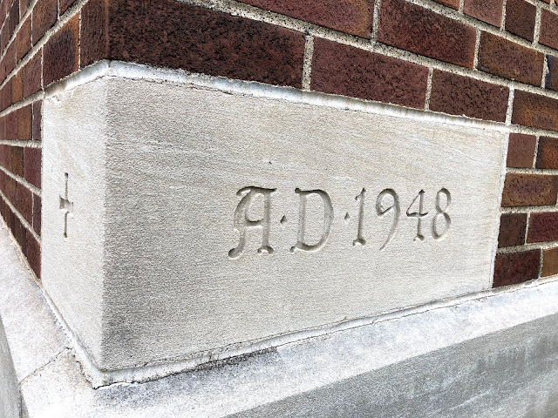
Ascension Convent in Minneapolis, Minn.
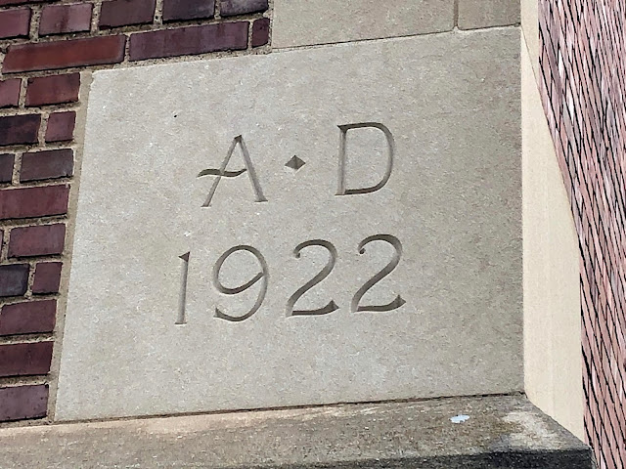
De La Salle High School in Minneapolis, Minn.
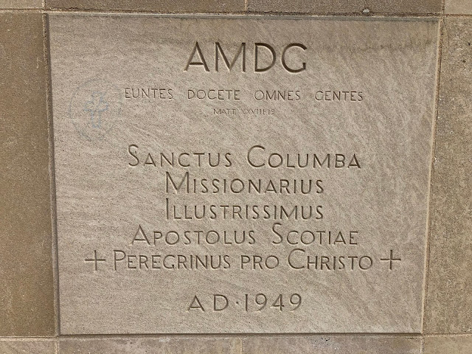
Church of St. Columba in St. Paul, Minn.
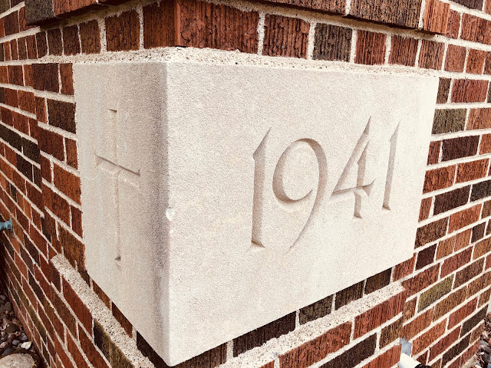
Holy Cross Convent in St. Paul, Minn.
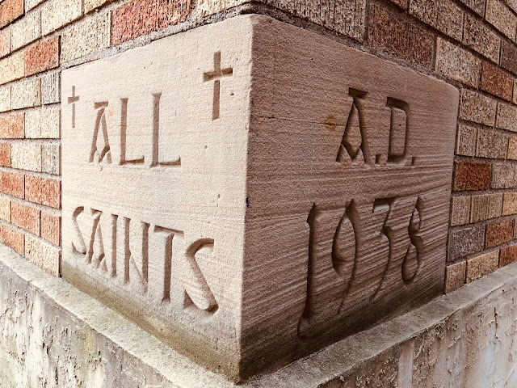
Church of All Saints in Minneapolis, Minn.
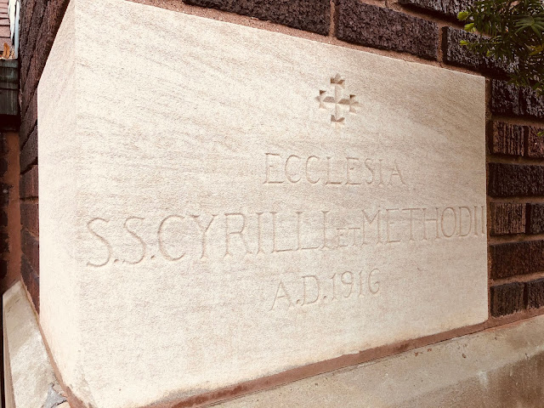
Church of Sts. Cyril and Methodius in Minneapolis, Minn.
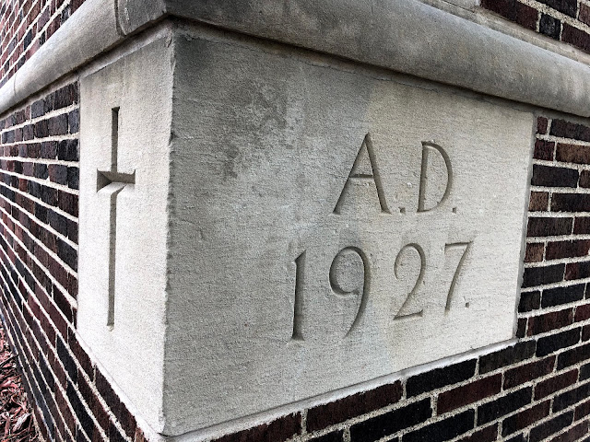
Ascension School in Minneapolis, Minn.
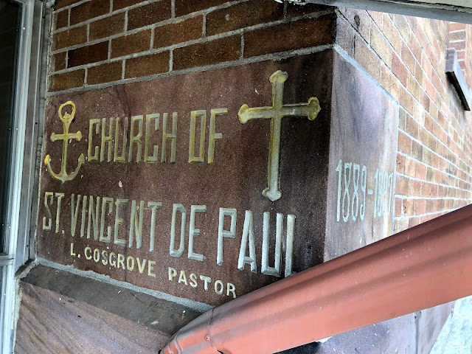
Church of St. Vincent de Paul in St. Paul, Minn.

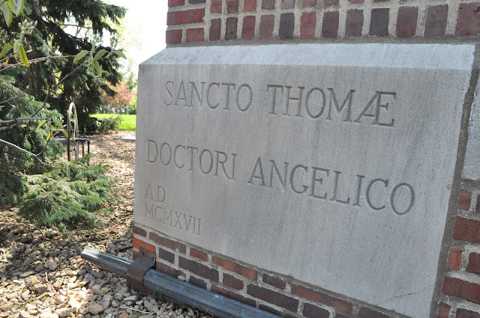

Chapel of St. Thomas Aquinas in St. Paul, Minn.

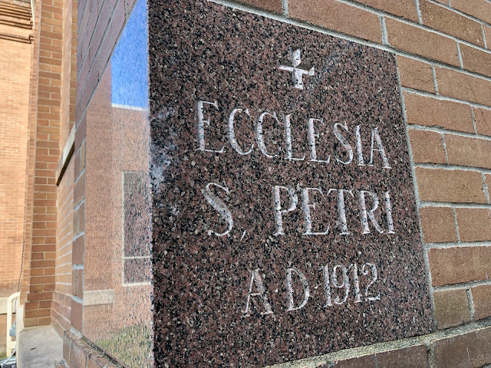

Church of St. Peter in Delano, Minn.

