Leighton Flowers Notes Sessions 1 Link https://www.youtube.com/watch?v=jgmJmY0-XdM
www.youtube.com/watch?v=RGdRQSpyjf8

Capturing Christianity
Dr. Braxtion Hunter The BEST Argument Against Calvinism w/ Dr. Braxton Hunter | V SHRED

Calvinists mentioned by Leighton.
John MacArthur
R.C. Sproul
J.I Packer
John Piper

Ministries
Grace at Hardin Simmons University

Not- Calvinist
A.W. Tozer The Knowledge of the Holy
C.S Lewis

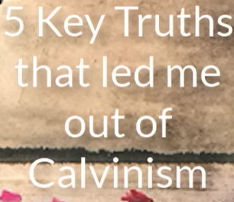

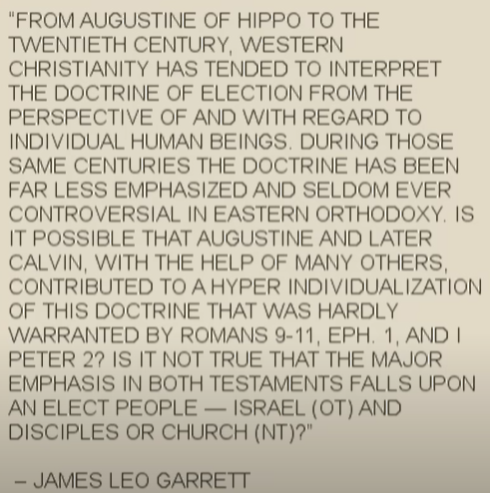

28:05

Comments on Note
@davidwhunt
7 years ago
Helpful video. One concern to me is when a Christian reads a LOT of Calvinistic books, and/or studies at a Calvinistic seminary, and then reads the Bible through Calvinistic eyes instead of reading it with an open mind. Once a mind is "locked into" Calvinism, it can make it difficult to correctly interpret the Bible because the Bible is approached with preconceived ideas. It's so important that we (whether Calvinistic, Arminian or other) read the Bible for what it is. and not approach it having already come to certain conclusions based on the teachings of men.

