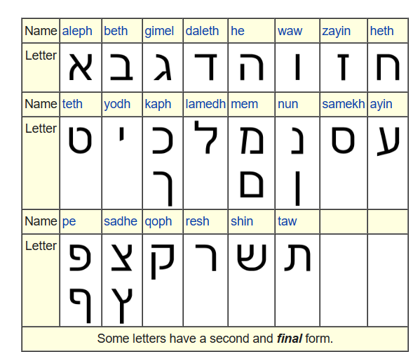
1:1 בְּרֵאשִׁית בָּרָא אֱלֹהִים אֵת הַשָּׁמַיִם וְאֵת הָאָרֶץ׃

בְּרֵאשִׁית
Bet:Schwa:Resh:Sere:Aleph:Shin:Hireq:Yod:Taw no dot
Transliteration B(e)rēshiyth (in) beginning

בָּרָא Bara Bet:Qames:Resh:Qames:Alef
Transliteration bārā created.

אֱלֹהִים
Aleph: Chataf Segol:Lamed:defective hollum:he:Hireqyod:final mem
Ehloheem God
אֵת
Aleph:Sere ( e as in obey):taw
Et and

הַשָּׁמַיִם
He:Patach:Shin:Qames:mem:patach:yod:hireq:final mem
Hawshamahyim
Okay the funny dot in the shin must be overriding the he:Patach. ?
Šāmayim

https://www.blueletterbible.org/assets-v3/images/audio/speaker3_b.svg

