Hebrew Alphabet

https://www.youtube.com/watch?v=12aQOQfpwZc

Alef
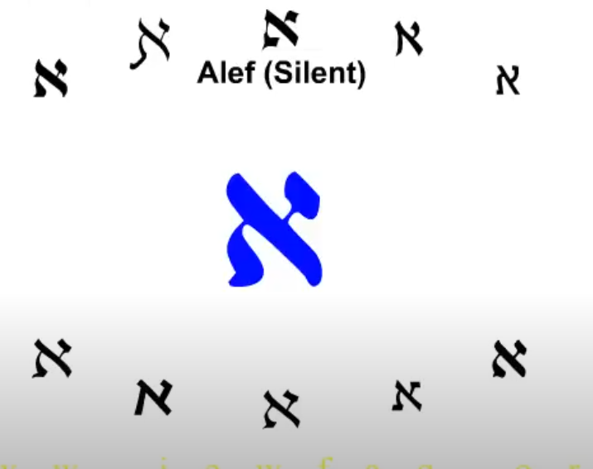  Alef is silent and makes no sound |  | 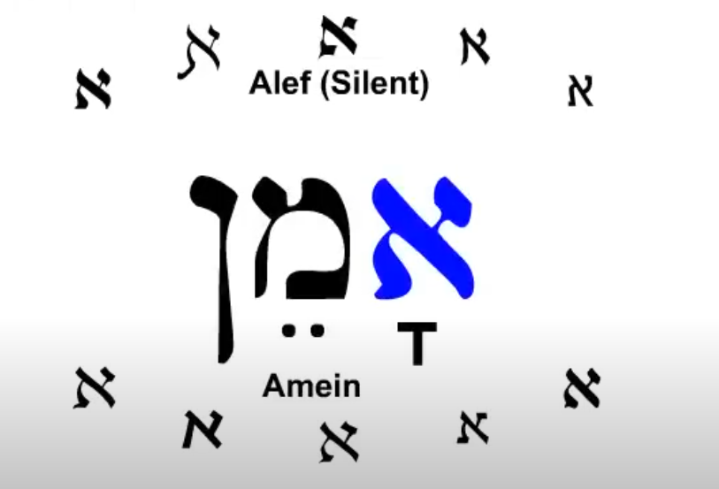
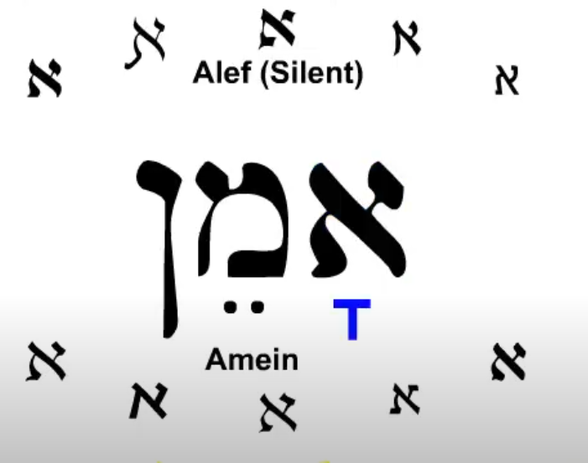  The sound for this word comes from the vowel mark below the Alef |  | 1st syllable Alef silent Kametz ah  2nd syllable  Mem .. (TBD) Final Nun

Hebrew Alphabet

https://www.youtube.com/watch?v=12aQOQfpwZc

Beit
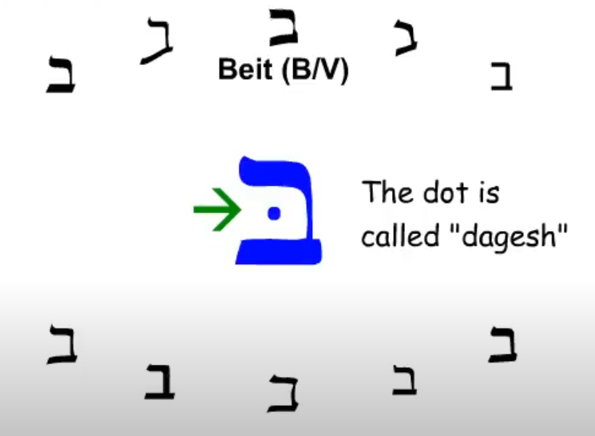  Beit makes a B or V sound. With the dot it is the B sound. The B sound is B as in Boy |  | 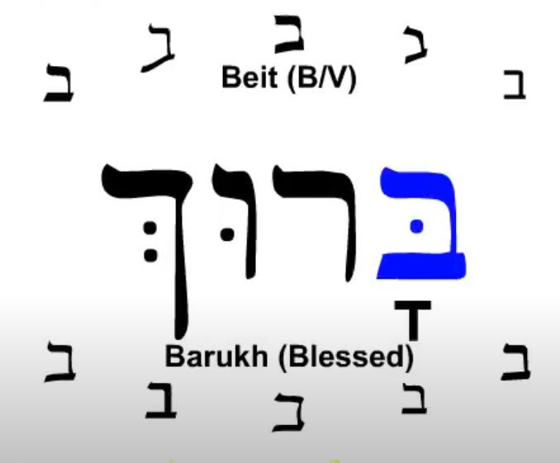
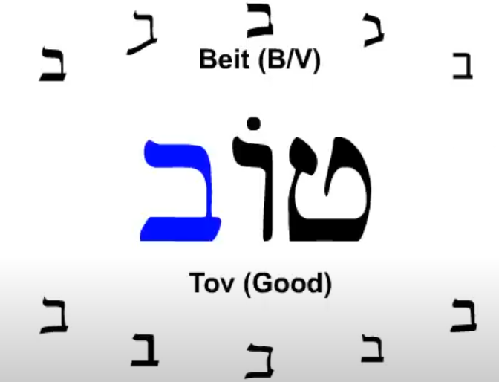

Beit with our the dagesh is sometimes called Veit and is the last letter of TOV the word for good. The V sound is V as in Victory.

Hebrew Alphabet

https://www.youtube.com/watch?v=12aQOQfpwZc

Gimel
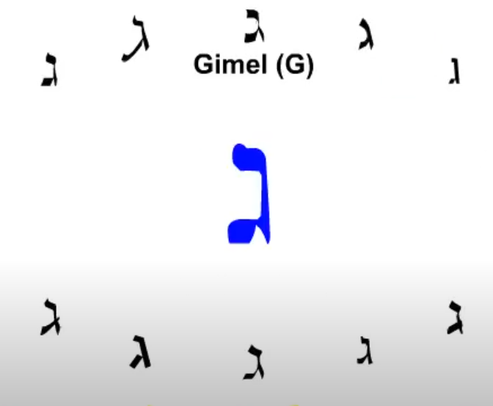  Hard g sound as in Good or Girl |  | 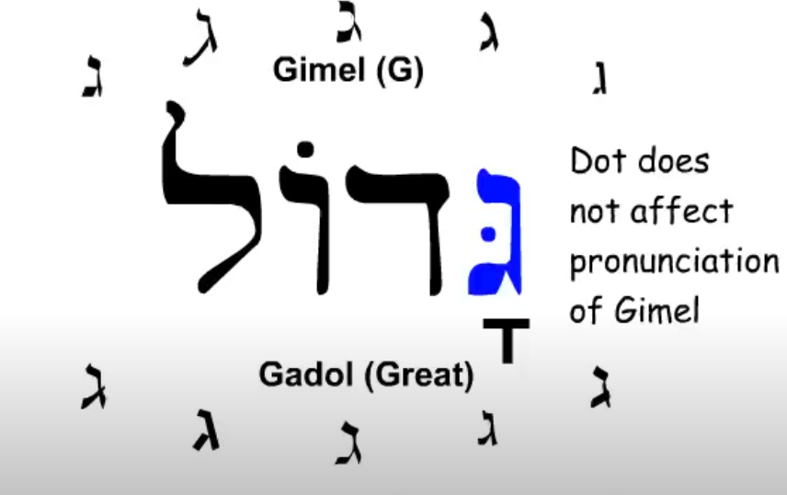  Some letters may contain dots that do not impact the pronunciation.

Hebrew Alphabet

https://www.youtube.com/watch?v=12aQOQfpwZc

Dalet
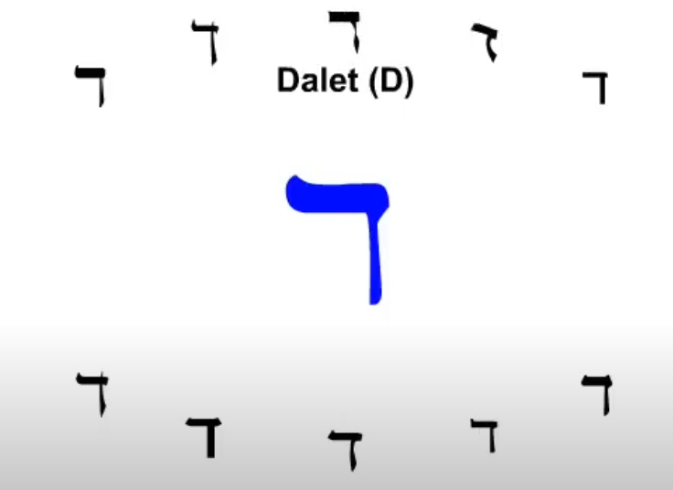  Dalet is shaped like the outline of a door and the word dalet actually means door. |  | 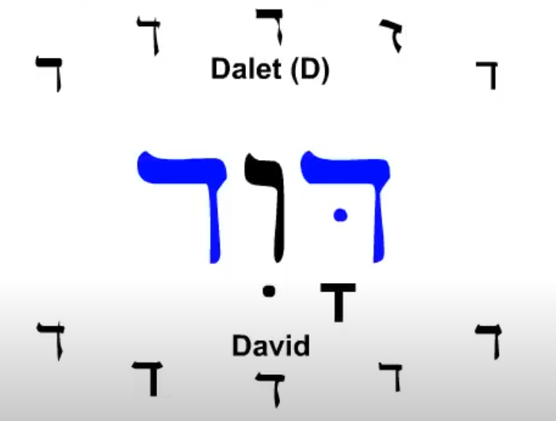

Hebrew Alphabet

https://www.youtube.com/watch?v=12aQOQfpwZc

Heh
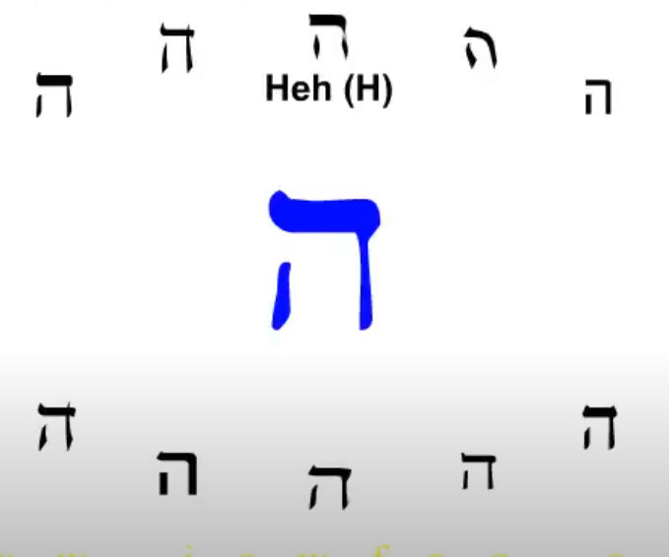  Heh makes the sound of H as in Hello. |  | 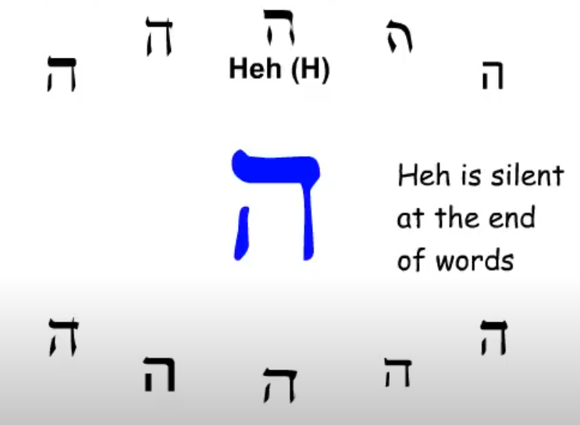
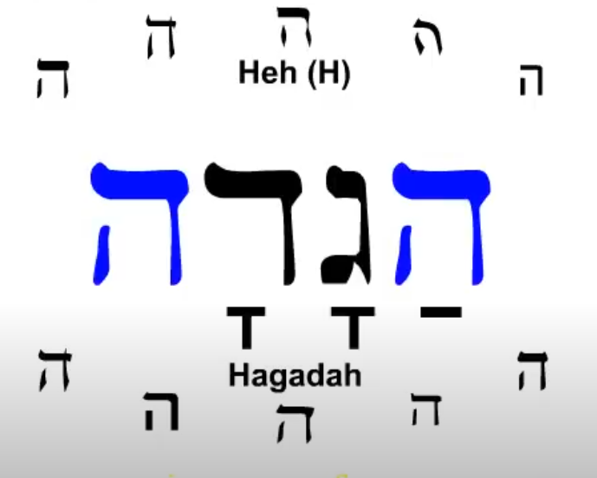  Ha Ga Da last Heh is silent. |  | Hagadah is the book read at the Jewish Passover Sadir (SP?)

Vav
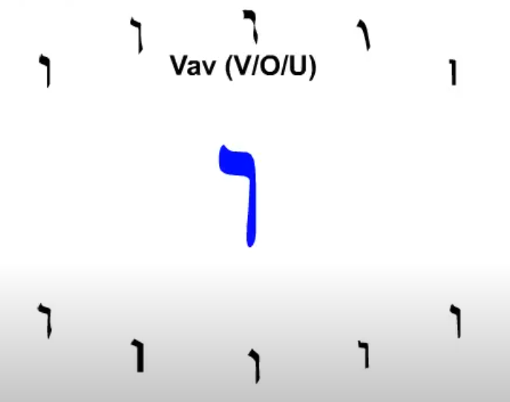  This is a tricky letter as it makes three different sounds. |  | 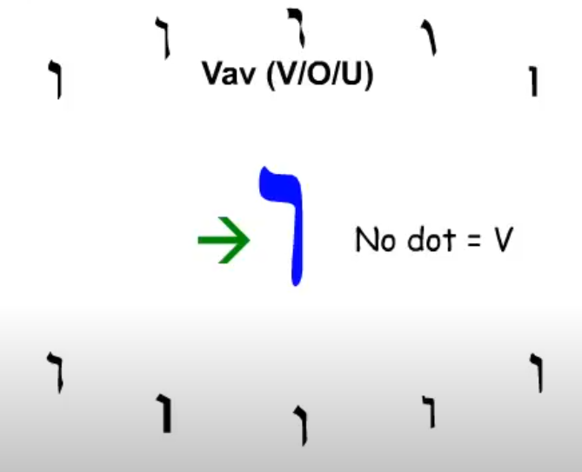  These are the basic rules for Vav. Thes can be impacted by adjacent vowels. Not dot is V as in Victory.
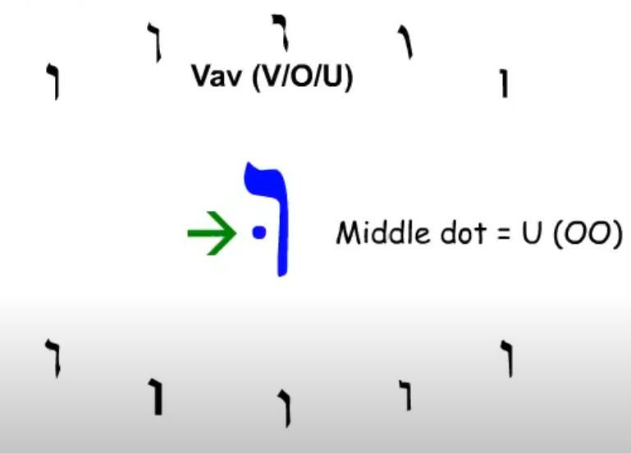  Middle dot is for U and is pronounced oo as in Google |  | 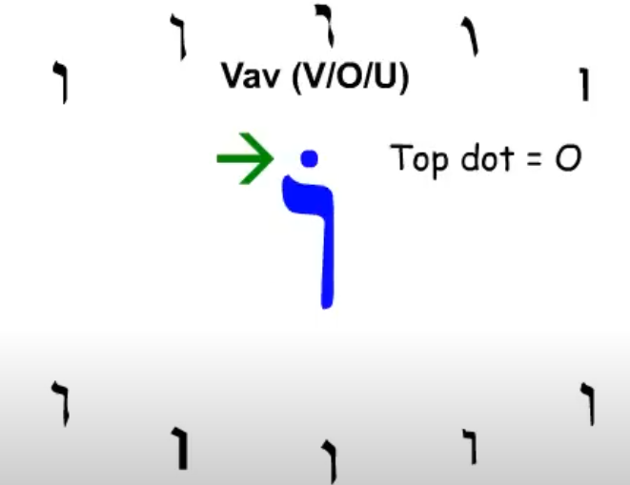  Pronounced as O in Open.
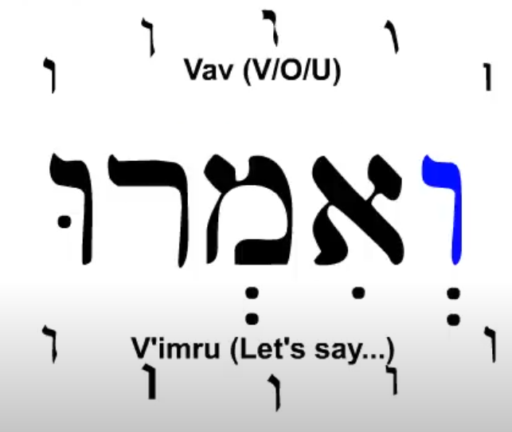  And let us say is V’imru is responded by Amein. |  | 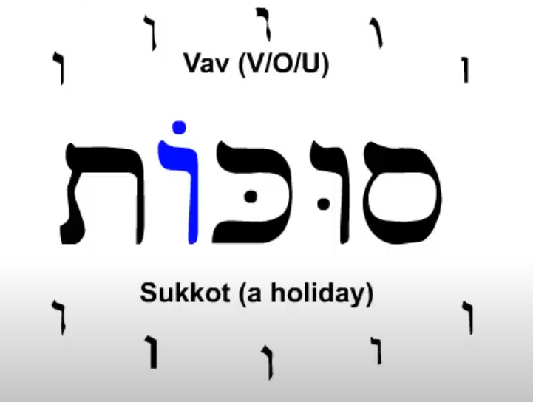  The O in sukkot is a long O. Sukkot is the feast of booths.

Hebrew Alphabet

https://www.youtube.com/watch?v=12aQOQfpwZc
Zayin
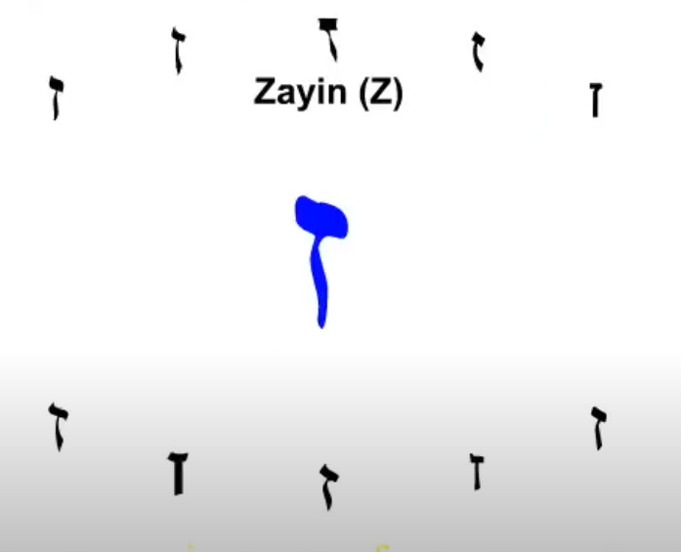  Zayin is pronounced as Z in Zero. |  | 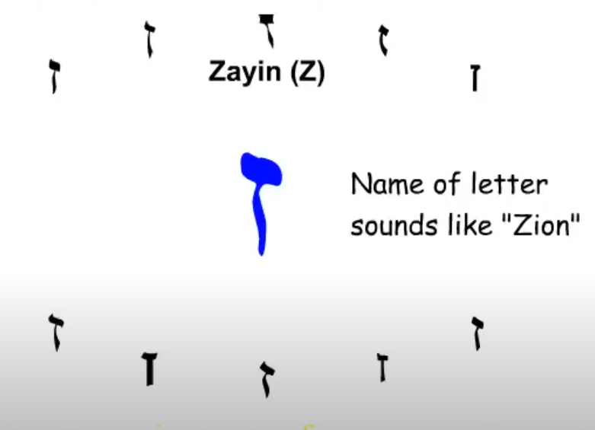  The name of the letter sounds like the English word zion but the Hebrew word for zion does not even begin with Zayin.
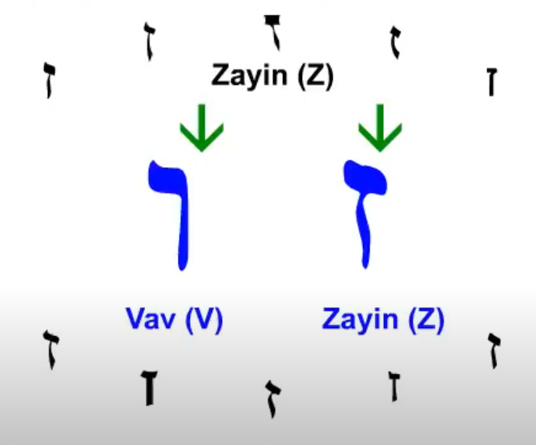  Both Vav and Zayin are narrow so take care in the small difference |  | 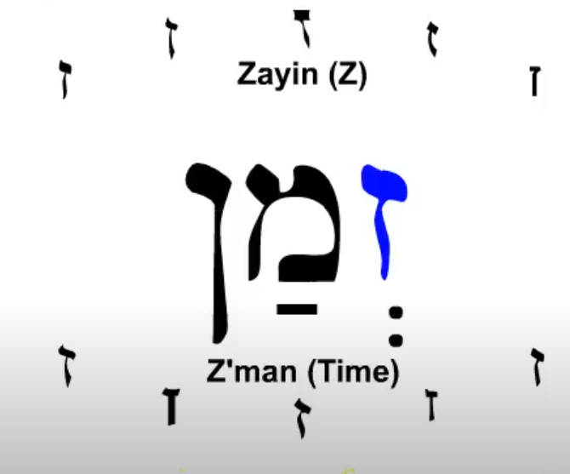  Time of day or a special time such as a holiday,

Hebrew Alphabet

https://www.youtube.com/watch?v=12aQOQfpwZc
Chet
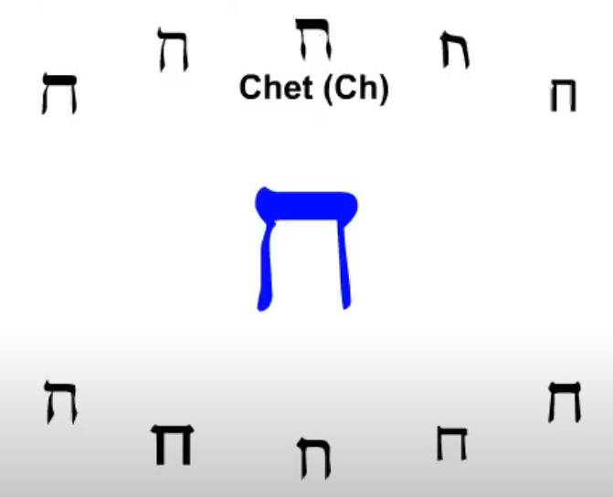  Chet has no equivalent sound is English but is the throat clearing sound as in the German akch. Or maybe the hocking of a loogy sound. There is no true C component in the sound that would be associated with Ch. |  | 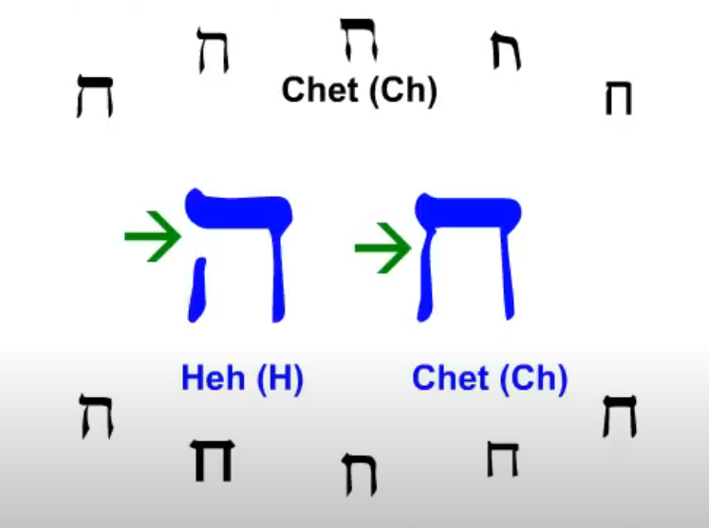  The letters are similar so note that the Heh has a hole on the left side.
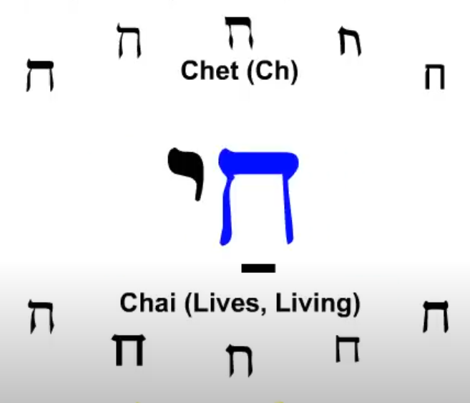

To pronounce Chai Ignore the C and think od the word High (or Hi) with the first H having the airy throat clearing sound.

Hebrew Alphabet

https://www.youtube.com/watch?v=12aQOQfpwZc

Tet
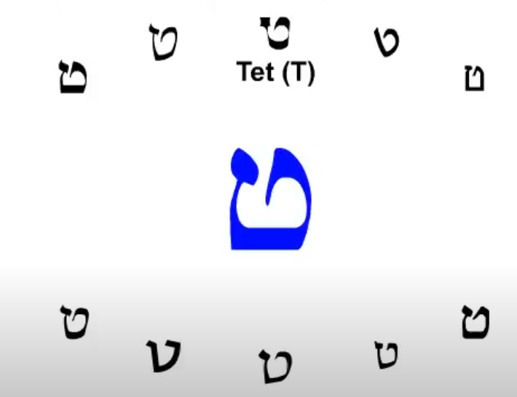  Tet makes a T sound as in Tango. |  | 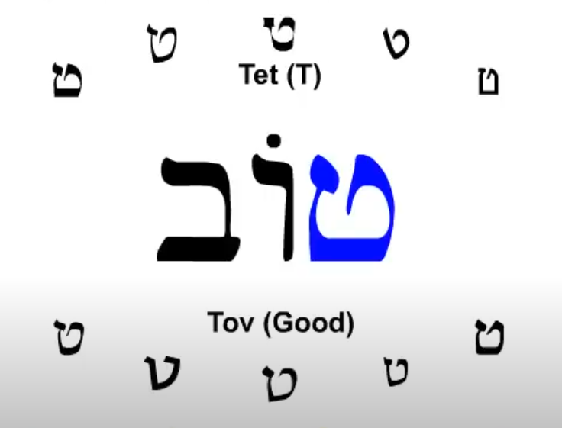  Tet is the first letter of Tov
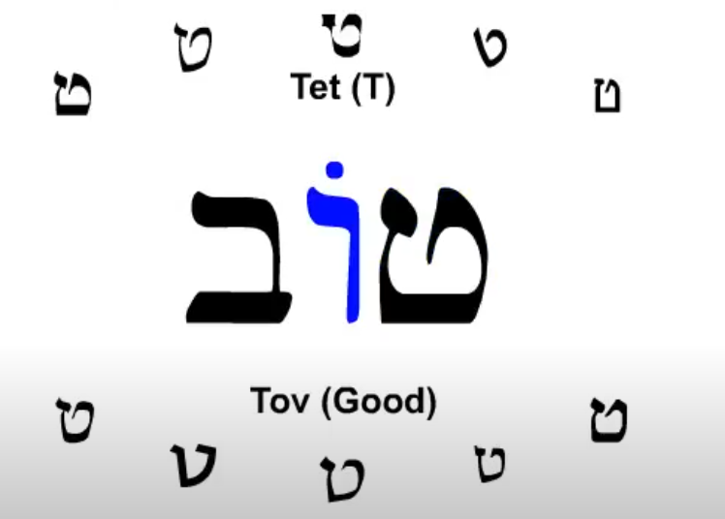  The second letter is Vav with the dot above giving the O as in Open sound. |  | 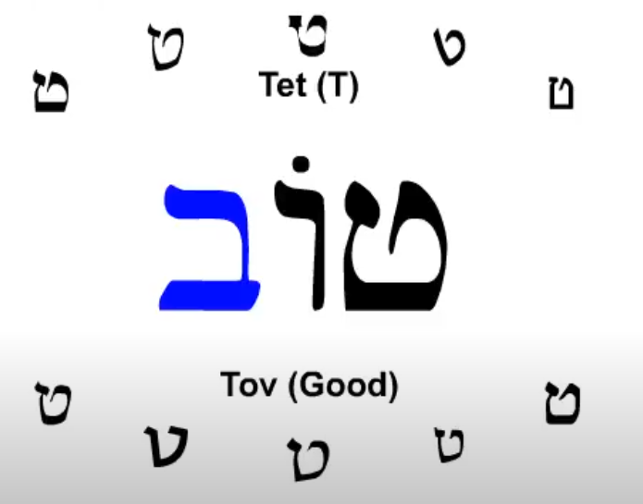  The last letter is Beit without a dot giving us the V as in victory sound.

Hebrew Alphabet

https://www.youtube.com/watch?v=12aQOQfpwZc

Yod (short o in letter name rhymes with could)
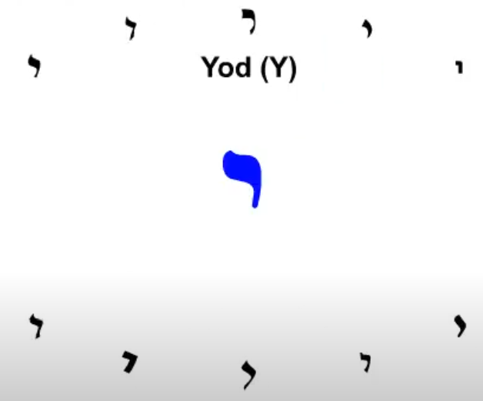  Yod is pronounced as a Y in Yellow. At the end of words it make take on the sound of adjacent vowel. |  | 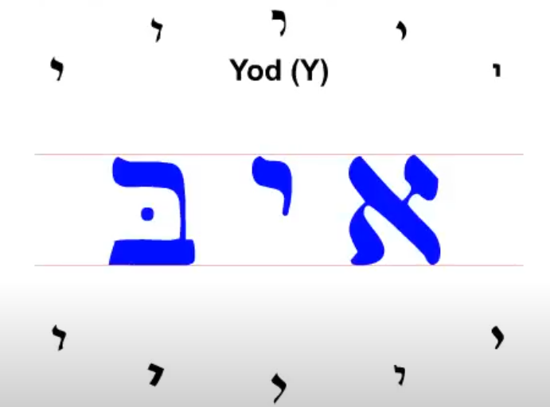  It it written at the top line of the letters that fill the topline to base line. Other small marks should be above the topline 0r below the base line.
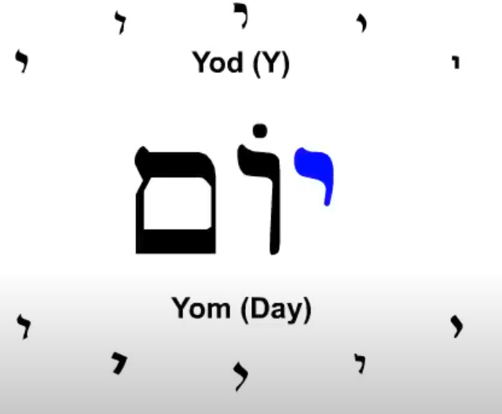

Hebrew Alphabet
https://www.youtube.com/watch?v=12aQOQfpwZc
Kaf
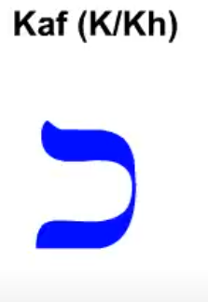  Kaf makes different sounds |  | 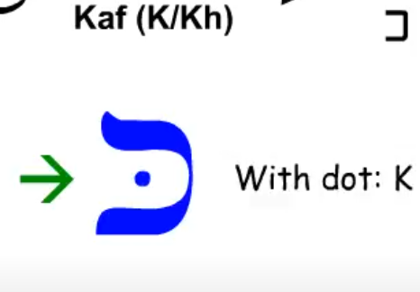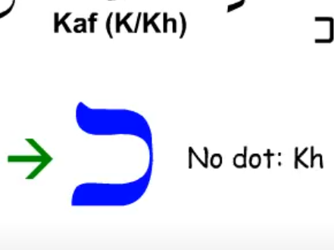  With the dot it makes the sound as in kangaroo. Without the dot Kay makes the throat clearing sound like Chet
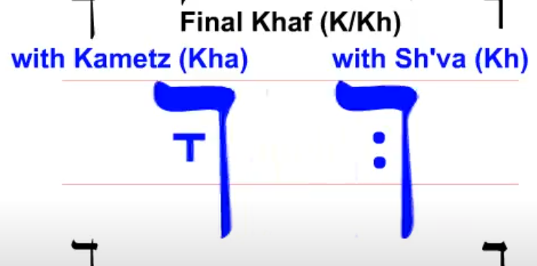  Final Kaf used at the end of words makes the throat cleating sound and contains an embedded vowel. |  | 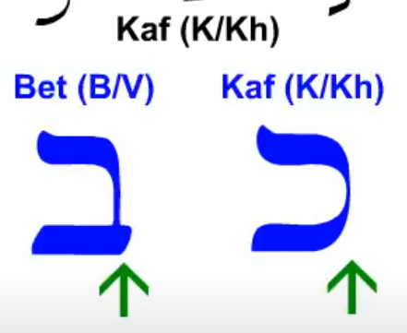  Kaf looks a lot like the letter Beit. Notice the baseline extension of Beit
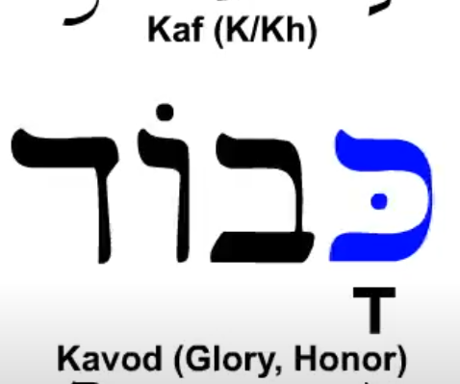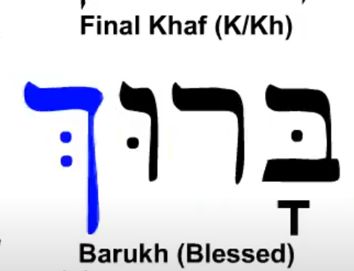  Barukh has a final Kaf that exteneds below the baseline and has an embedded Sh’va. |  | 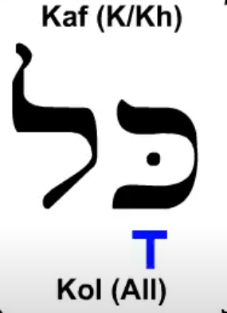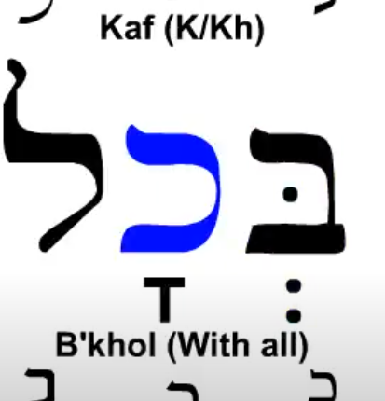  The Kametz makes an o sound in this word instead of the normal ah sound. Just a variation but a very common word. B’Khol kas a Beit prefix meaning with.

Hebrew Alphabet

https://www.youtube.com/watch?v=12aQOQfpwZc

Lamed
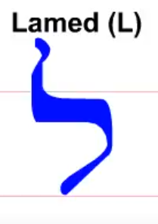  Lamed is L as in light. It is the only letter that goes above the topline. |  | 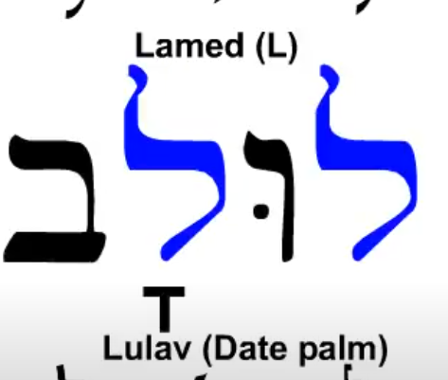

Hebrew Alphabet
https://www.youtube.com/watch?v=12aQOQfpwZc
Mem
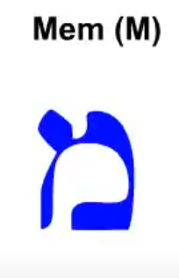  Mem is pronounced as M in Mary. |  | 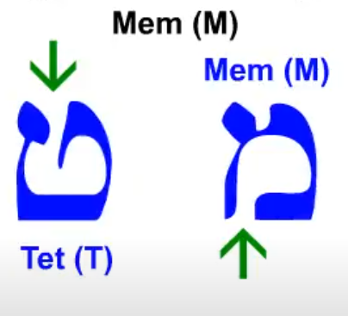  Sometimes is may look as the letter Tet but the opening is at the bottom
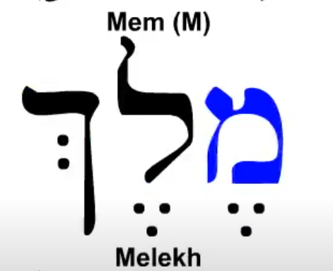  Mem is the first letter in the word Melekh which means king or ruler. |  | 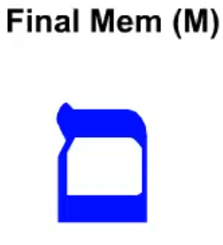  Final Mem is the only final letter that does not extend below the baseline.
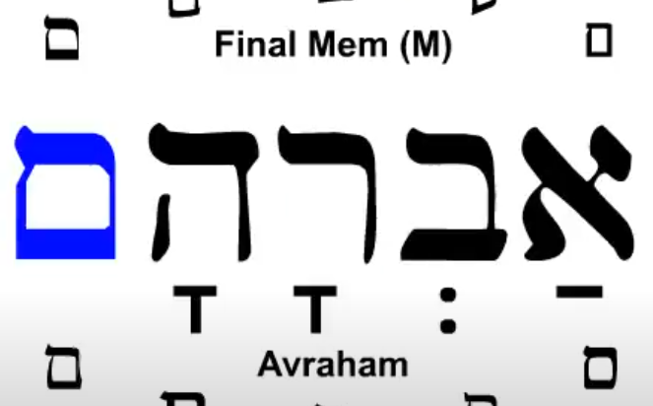

Final Mem occurrs at the end of Avraham.

Hebrew Alphabet
https://www.youtube.com/watch?v=12aQOQfpwZc
Nun
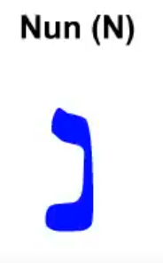  Nun makes a sound as N in Nancy. |  | 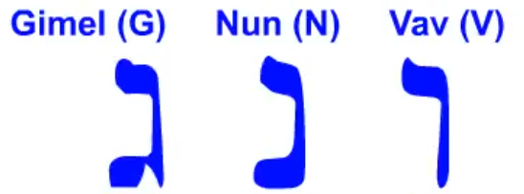  Thess letters are narrow and can be confusing. Vav has no baseline. Nun has a solid baseline. Gimmel has a baseline with a gap.
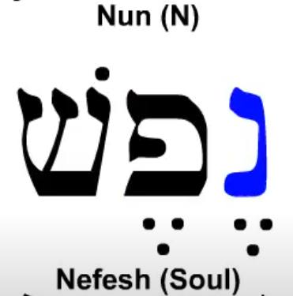  The sound for this word comes from the vowel mark below the Alef |  | 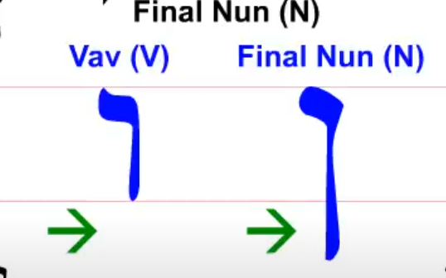  Final Nun extends below the base line. This is to distinguish it from Vav.
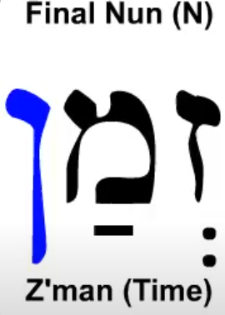

Hebrew Alphabet
https://www.youtube.com/watch?v=12aQOQfpwZc
Samekh
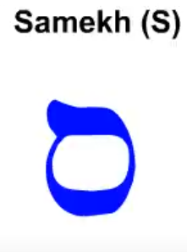  Samek S sound as S in Sound. To me it looks like a sigma written backwards. |  | 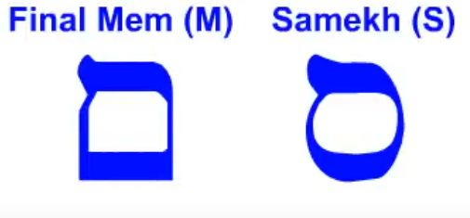  Samekh is diffentiated from Final Mem by being a circle. Final Mem only accors at the end of a word while Samekh can be in any position.
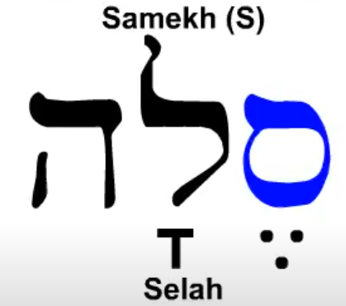

Selah occurs many time in Psalms but the meaning is noy truly known.

Hebrew Alphabet
Hebrew Alphabet Part 3 (youtube.com)
Ayin
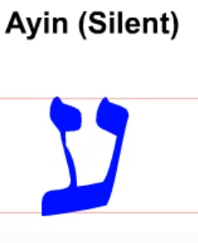  Ayin is Silent and dips slightly below the baseline. |  | 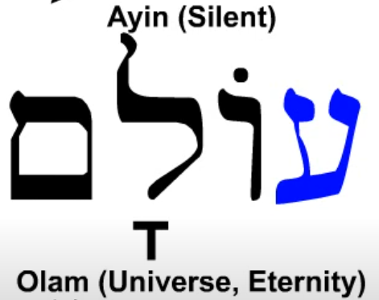  Olam begins with the silent Ayin and means universe, eternity , or forever and ever.

Selah occurs many time in Psalms but the meaning is noy truly known.

Hebrew Alphabet
https://www.youtube.com/watch?v=12aQOQfpwZc
Samekh
Samek S sound as S in Sound. To me it looks like a sigma written backwards. |  | Samekh is diffentiated from Final Mem by being a circle. Final Mem only accors at the end of a word while Samekh can be in any position.

Selah occurs many time in Psalms but the meaning is noy truly known.

Hebrew Alphabet
https://www.youtube.com/watch?v=12aQOQfpwZc
Samekh
Samek S sound as S in Sound. To me it looks like a sigma written backwards. |  | Samekh is diffentiated from Final Mem by being a circle. Final Mem only accors at the end of a word while Samekh can be in any position.

Selah occurs many time in Psalms but the meaning is noy truly known.

Hebrew Alphabet
https://www.youtube.com/watch?v=12aQOQfpwZc
Samekh
Samek S sound as S in Sound. To me it looks like a sigma written backwards. |  | Samekh is diffentiated from Final Mem by being a circle. Final Mem only accors at the end of a word while Samekh can be in any position.

Selah occurs many time in Psalms but the meaning is noy truly known.

Hebrew Alphabet
https://www.youtube.com/watch?v=12aQOQfpwZc
Samekh
Samek S sound as S in Sound. To me it looks like a sigma written backwards. |  | Samekh is diffentiated from Final Mem by being a circle. Final Mem only accors at the end of a word while Samekh can be in any position.

Selah occurs many time in Psalms but the meaning is noy truly known.

Hebrew Alphabet
https://www.youtube.com/watch?v=12aQOQfpwZc
Samekh
Samek S sound as S in Sound. To me it looks like a sigma written backwards. |  | Samekh is diffentiated from Final Mem by being a circle. Final Mem only accors at the end of a word while Samekh can be in any position.

Selah occurs many time in Psalms but the meaning is noy truly known.

Hebrew Alphabet
https://www.youtube.com/watch?v=iNHnxOoWBIU Part 2
Vowels
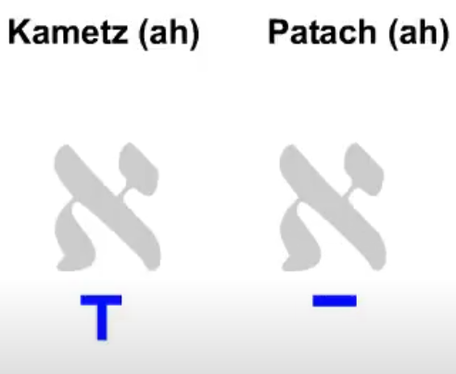  Kametz and Patach have the ah sound pronounced as the a in father. The ch in Patach is the throat clearing sound. |  | 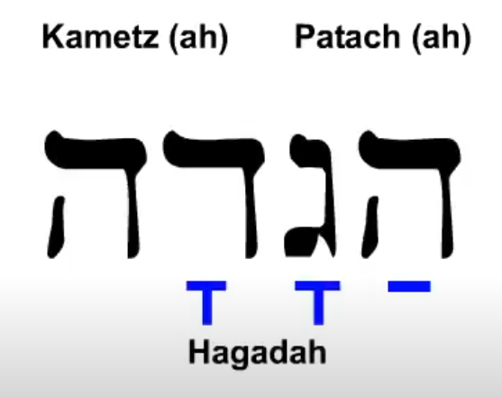  1st t syllable Heh Patach Ha  2nd syllable Gimel Kametz ga  3rd syllable Dalet Kametz da  Final Heh is silent.
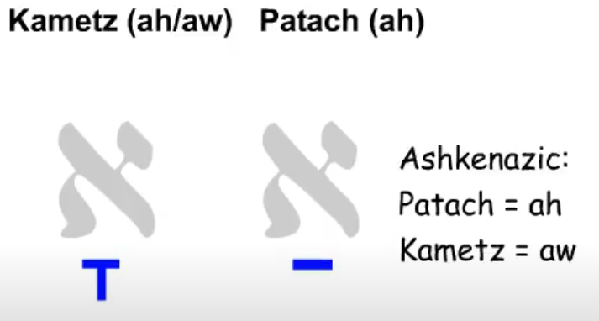  This is a pronunciation used by the German, Eastern European and Orthodox Jews. |  | 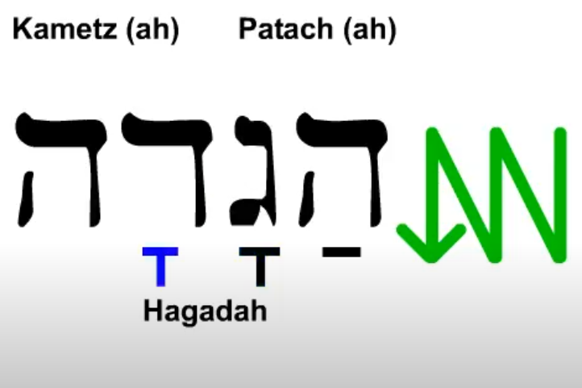  The words are read in a consonant Vowel  groups left to right in a zigzag fashion
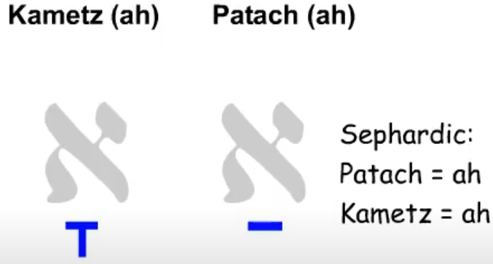

Used in Israel today.

Hebrew Alphabet
https://www.youtube.com/watch?v=iNHnxOoWBIU Part 2
Vowels
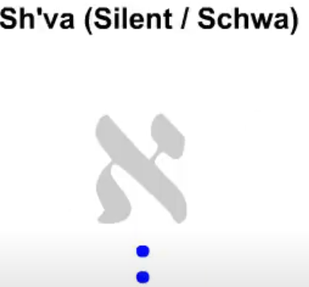  Sh’va is used as a place holder when there is no vowel sound |  | 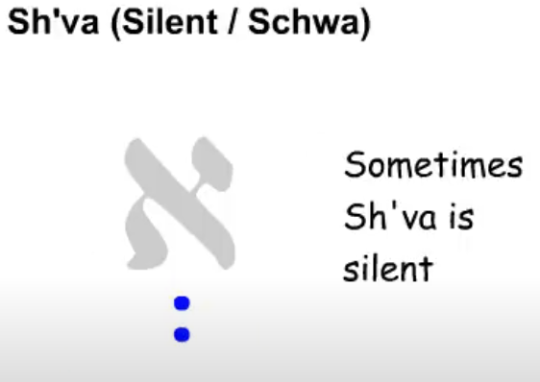
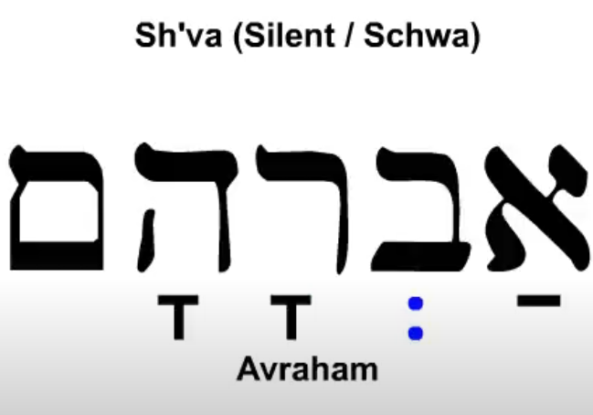  Silent Sh’va in this case |  | 1st t syllable Aleph Patach ah  2nd syllable Veit no vowel V  3rd syllable Dalet Kametz da  Final Heh is silent
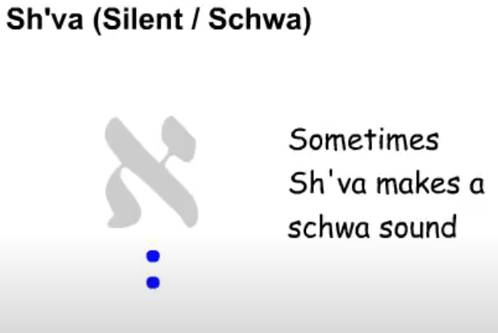  Somtivse Sh’va makes a generic unstressed vowel sound identified by linguist as the schwa. I.E. a in alone, e in begin, u in circus. |  | 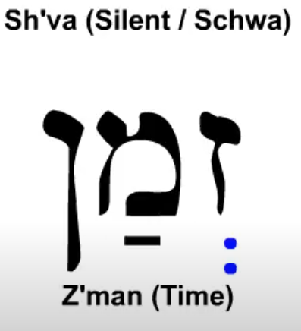  If the Sh’va is the first vowel it is pronounced. It other cases it can be pronounced by is usually silent. More complex rules later.

Hebrew Alphabet
https://www.youtube.com/watch?v=iNHnxOoWBIU Part 2
Vowels
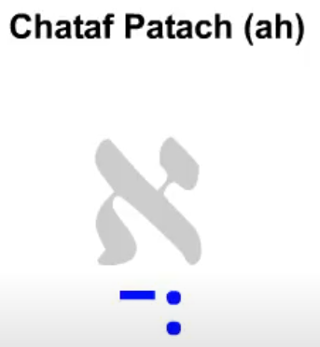  Chataf Pattach also make the ah sound but is unstressed. The two symbols are not two vowels. |  | 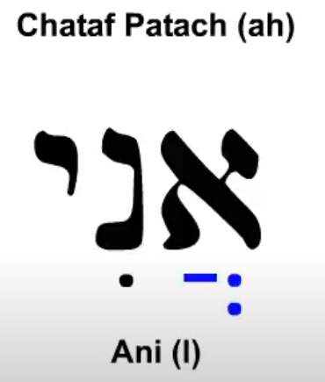  The first syllable is unstress while the second syllable is stress in this case.
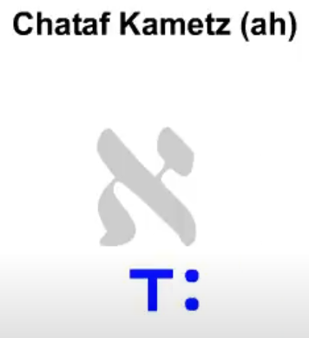
Chataf Kametz also an unstressed aw sound. This one does not occur very often.

Hebrew Alphabet
Hebrew Alphabet Part 3 - YouTube
Vowels
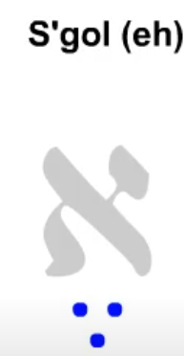  S’gol is the short e sound as e in bed. |  | 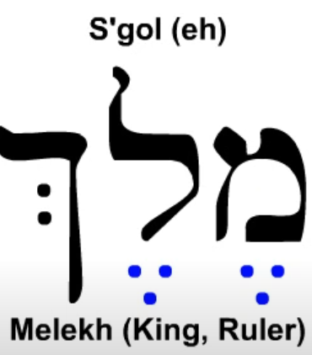  S’gol is used twicw in Melekh
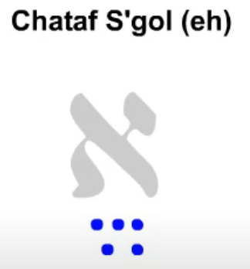  Chataf S’gol has the short e sound and is unstressed. |  | 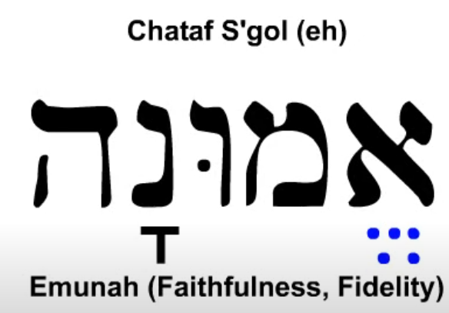

Hebrew Alphabet
https://www.youtube.com/watch?v=iNHnxOoWBIU Part 2
Vowels
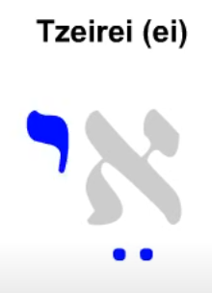  This is pronounced as the ei in neighbor |  | The first syllable is unstress while the second syllable is stress in this case.
Chataf Kametz also an unstressed aw sound. This one does not occur very often.

Hebrew Alphabet
Hebrew Alphabet Part 3 - YouTube
Vowels
S’gol is the short e sound as e in bed. |  | S’gol is used twicw in Melekh
Chataf S’gol has the short e sound and is unstressed.

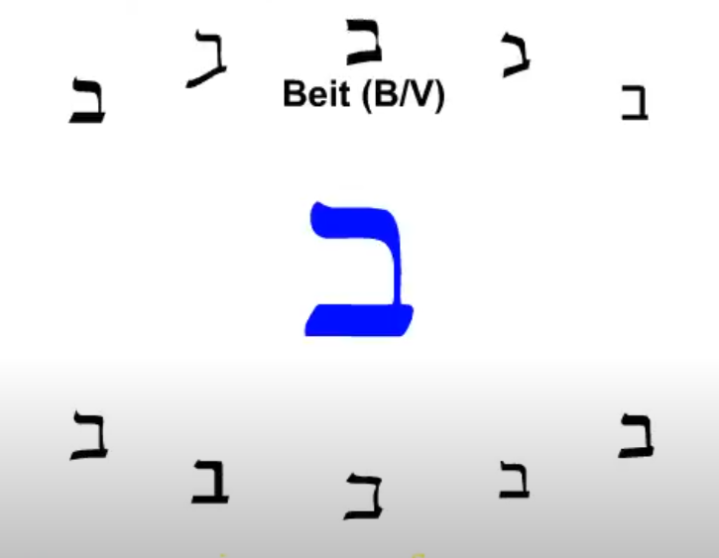

The Beit has a dot inside for the B sound and no dot for the V sound.
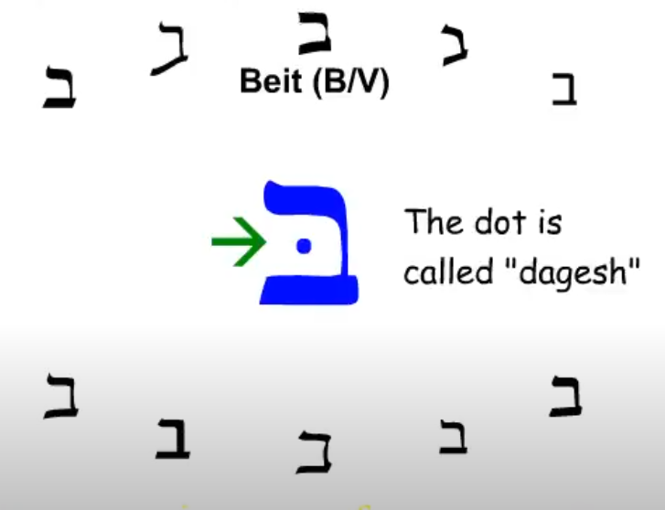

Hebrew Alphabet (Just the Letters) (youtube.com)

