July 22, 1954
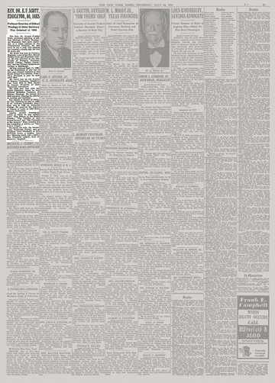
Credit...The New York Times Archives
See the article in its original context from
July 22, 1954, Page 23Buy Reprints
New York Times subscribers* enjoy full access to TimesMachine—view over 150 years of New York Times journalism, as it originally appeared.
Subscribe
*Does not include Crossword-only or Cooking-only subscribers.
About the Archive
This is a digitized version of an article from The Times’s print archive, before the start of online publication in 1996. To preserve these articles as they originally appeared, The Times does not alter, edit or update them.
Occasionally the digitization process introduces transcription errors or other problems; we are continuing to work to improve these archived versions.
The Rev. Dr. Ernest Findlay Scott, professor emeritus of biblical theology of Union Theological Seminary, died early yesterday of a heart ailment at the Presbyterian Hospital. He had been ill for a year and entered the hospital a month ago. He was 86 years old.
Mr. Scott was born in Durham, England, a son of the Rev. Ernest Fidelis Scott and Elizabeth Couttie. He was educated at the University of Glasgow, Scotland; Balliol College, Oxford University, and the United Presbyterian College in Edinburgh. He was ordained Sept. 11, 1895, by the Presbytery of Ayr and in that year became minister of the South United Free Church, Prestwick, Scotland, a post he held until 1908.
Mr. Scott was on the faculty of Queen's University, Kingston, Ont., from 1908 to 1919, where he became Professor of New Testament Literature. His next post was with the Union Seminary, where he was Edward Robinson Professor of Biblical Theology. He retired in 1938 and later directed his efforts to writing and teaching.
The degree of Doctor of Divinity was conferred on him in 1909 by St. Andrews University, Scotland, and in 1939 by Amherst College. He received the degree of Doctor of Laws in 1920 from Queen's University.
Among several theological works of which he was author were: “The Nature of the Early Church,” “The Validity of the Gospel Record” and “The Purpose of the Gospels.” More recently he had completed a volume on “The Lord's Prayer.”
He leaves his wife, the former Annie Roxburgh Dunlop, and a daughter, Nora Elizabeth, of 445 Riverside Drive; a brother, the Rev. Ebenezer Scott, and a sister, Mrs. Elizabeth Liggett, both of Somerset, England.

