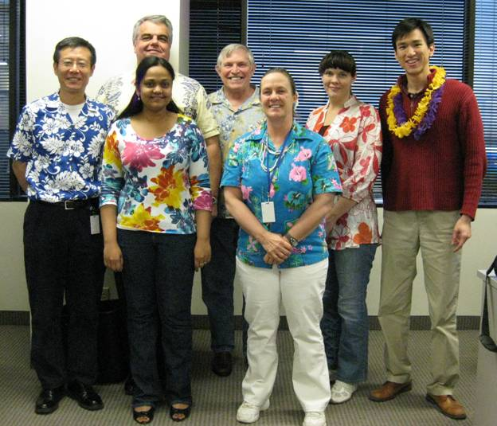

Diodes Aloha Friday February 26, 2010
Front Row: Jennifer Joseph, Margo Moore
Back Row:
Dongjie Chen, Weldon Beardain, Keith Appel, Margo Moore, Cynthia Noe, Yen-Linang Lin

I know that Cynthia has come form the Westlake CA, office and maybe Margo had done th the same.

